Technical File
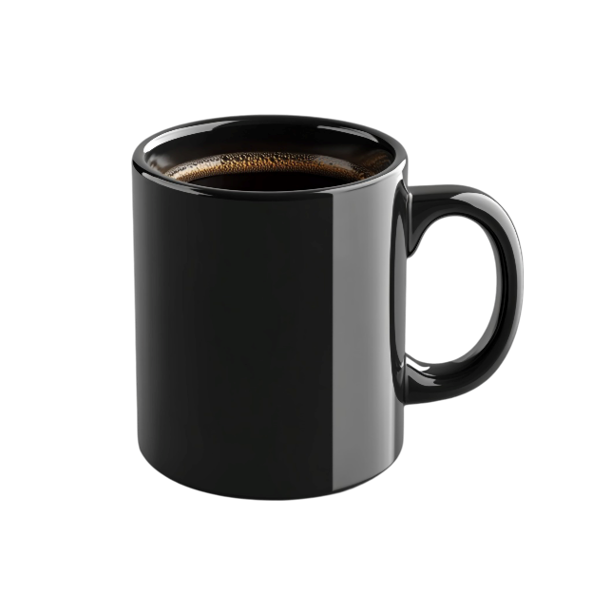

Basic information
Product name: Ceramic Coffee Mug
Model: CM-01
Product type: Consumer kitchen product

Product description
Ceramic mug intended for drinking hot and cold beverages. Suitable for daily household use by all age groups under normal and reasonable use.

Main characteristics
Material: Glazed ceramic
Capacity: 300 ml
Use: Hot and cold drinks

Economic operators
Manufacturer:
Company X
Address
Postal code, City, Country
E-mail or website
EU Authorised Representative:
Westwood Sourcing
Fellenoordstraat 52, unit 2.38
4811 TJ Breda, Netherlands
info@westwoodsourcing.com

Product Identification & Traceability
Model: CM-01
Batch number: [e.g. B2026-01]
Supplier: [Factory name, China]
Traceability system:
Batch number printed on packaging and linked to production records.

Risk Assessment
Risk | Likelihood (0-5) | Severity (0-5) | Risk Level (L*S) | Mitigation
1. Small parts breaking off creating a choking hazard | 1 | 5 | 5  (low) | Improve design
2. Handle breaking during normal use | 2 | 4 | 8  (moderate) | Use stronger material
3. Cracking due to temperature changes | 2 | 4 | 8  (moderate) | Define safe usage
4. Glaze could contain harmful substances | 1 | 5 | 5  (low) | Perform testing

Likelihood | Severity | Risk level
1 Rare: Very unlikely to happen  2 Unlikely: Could happen, but not expected  3 Possible: Might happen sometimes  4 Likely: Will happen regularly  5 Very likely: Expected to happen frequently | 1 Negligible: No injury or very minor inconvenience  2 Minor: Small cuts or irritation  3 Moderate: Injury requiring basic treatment (e.g. minor burn)  4 Serious: Significant injury (e.g. serious burn)  5 Severe: Life-threatening or permanent injury | 1-5 Low risk  Minor concern, but still considered  6-10 Moderate risk  Needs attention and control measures  11-15 High risk  Action required to reduce risk  16-25 Critical risk  Immediate action required

Risk = Likelihood × Severity
This gives a score between 1 and 25.

Applicable regulations
☒ | General Product Safety Regulation (GPSR) | Regulation (EU) 2023/988
☒ | Registration, Evaluation, Authorisation and Restriction of Chemicals (REACH) | Regulation (EU) 1907/2006
☐ | Classification/labelling of chemical substances & mixtures (CLP) | Regulation (EU) 1272/2008
☐ | Low Voltage Directive (CE-LVD) | Directive 2014/35/EU
☐ | Electromagnetic conductivity (CE-EMC) | Directive 2014/30/EU
☐ | Radio Equipment Directive (CE-RED) | Directive 2014/53/EU
☐ | Toy Safety Directive | Directive 2009/48/EC
☐ | Electronics restriction on hazardous substances (RoHS) | Directive 2011/65/EU
☐ | Waste electrical and electronic equipment (WEEE) | Directive 2012/19/EU
☒ | Packaging & Packaging Waste | Directive 94/62/EC
☐ | Ecodesign | Directive 2009/125/EC
☐ | Energy Labelling | Regulation (EU) 2017/1369
☐ | Textile labeling | Regulation (EU) 1007/2011
☒ | Food-contact materials | Regulation (EU) 1935/2004
☐ | Other <fill in here>

Markings
Warnings placed on the label should be a result of your risk assessment’s risk mitigation.

Ceramic Coffee Mug – Black
Warning: Rapid temperature changes may cause the mug to crack or shatter, posing a risk of injury.
SKU: CUPBLACK BATCH: 08-2026
Manufacturer: EU Authorised Representative
Company X Company Y
Street 12 Street 142
Postal code, Country Postal code, EU Country
www.coffeemugs.com hello@euauthrep.com

Complaints & modifications
Keep track of complaints and modifications here. Write down what the complaint or change was, and whether there are new risks (and how you mitigated them).

Test Reports
Add your test reports here

